Optimization of Pin-Fin Arrays for Helium-Cooled Finger-Type Divertor

J. D. Rader, B. H. Mills, D. L. Sadowski, M. Yoda, and S. I. Abdel-Khalik

G. W. Woodruff School of Mechanical Engineering, Georgia Institute of Technology, Atlanta, GA 30332-0405 USA
said.abdelkhalik@me.gatech.edu

The helium-cooled modular divertor concept with integrated pin array developed by the Karlsruhe Research Center (FZK) is unusual among helium-cooled tungsten divertor designs in that it relies upon an array of pin fins on the back of the cooled surface, instead of jet impingement, to cool the plasma-facing surface. The Georgia Tech group experimentally studied a similar design constructed of brass which combined jet impingement with an array of identical cylindrical pin fins using air at nondimensional coolant mass flow rates, i.e. Reynolds numbers, which spanned the range expected under prototypical conditions. The results suggested that the pin-fin array, at least for the particular geometry studied, provides little, if any, additional cooling beyond that provided by jet impingement.
Given that this earlier study considered only one pin-fin array geometry, however, a numerical study was performed to investigate whether changes in the array geometry could improve performance. Specifically, numerical simulations using the commercially available computational fluid dynamics software package ANSYS® 14.0 was used to examine how varying the pitch-to-diameter ratio for the fin array and the aspect ratio of the fins affected average pressure boundary temperature and the pressure drop across the divertor. These results can, with appropriate experimental validation, be used to determine whether pin-fin arrays can be used to improve the thermal performance of a variety of helium-cooled tungsten divertors.
I. Introduction
Several gas-cooled divertor designs have been studied as part of the ARIES project including the helium-cooled multi-jet¹ (HEMJ), helium-cooled flat plate² (HCFP), and the helium-cooled divertor with multi-pin array³ (HEMP). All these divertors are designed to remove heat fluxes of at least 10 MW/m² incident on the plasma-facing tungsten tiles while remaining within temperature and thermal stress limits dictated by material properties. The HEMJ and HCFP designs use impinging round or planar jets as the primary means of removing heat from the pressure boundary, and hence the plasma-facing tiles. The HEMP, however, was designed to use cooling fins integral to the inside surface of the pressure boundary as a way to increase heat removal effectiveness of the coolant. As the relatively complicated fins of the original HEMP design proved difficult to manufacture⁴, a simpler design with an array of identical cylindrical pin fins was constructed and experimentally tested at Georgia Tech^{5,6}. Following these experiments, a numerical study was performed that included searching for a more optimal fin layout to enhance the divertor module cooling effectiveness without adversely impacting the required coolant pumping power.
II. The HEMP Divertor

The HEMP divertor is shown in Fig. 1. Helium at 600 °C and 10 MPa enters via an annular channel and flows radially inward through an array of cooling fins before exiting axially through a central port at ~700 °C. Nearly 4×10⁵ of these modules are required to cool the 100 m² area of the plasma-facing surface of the divertor.
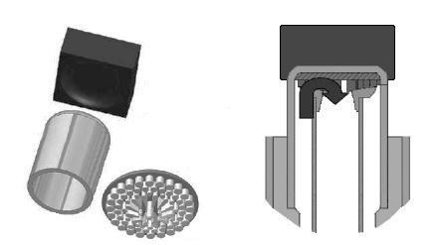
Φ 6
Φ 4
Φ 12
0.5
15.8
Tile
Shell
Pin Fin Array
5
Φ 14
Fig. 1. The HEMP divertor exploded [left] and cross sectional view [right]. All dimensions in mm.
A design similar to the HEMP divertor module was studied experimentally^{5,6} and numerically⁷ at Georgia Tech using a test section constructed from brass heated with an oxy-acetylene torch at heat fluxes up to 2 MW/m², and cooled with air, argon (Ar), or helium (He) entering at nearly ambient temperatures and pressures up to 1.4 MPa (Fig. 2). These experiments were designed so that the coolant flow was either “forward flow” or “reverse flow.” In reverse flow, the coolant, similar to the original HEMP design, reaches the outer edge of the cooled surface of the pressure boundary via an annular channel, then flows radially inward through the pin-fin array. In forward flow, the coolant impinges on the cooled surface as a round jet that exits the central port, and then flows radially outward through the fin array. The earlier studies conducted at Georgia Tech concluded that the forward flow configuration had a cooling performance similar to, but a pressure drop greater than, the reverse flow configuration at prototypical conditions, due to the increase in pressure drop associated with the impinging jet. More recent estimates⁶ show, however, that the forward flow configuration, with its combination of two cooling methods (fins and impinging jet) does, in fact, have superior cooling performance compared with the reverse flow case.
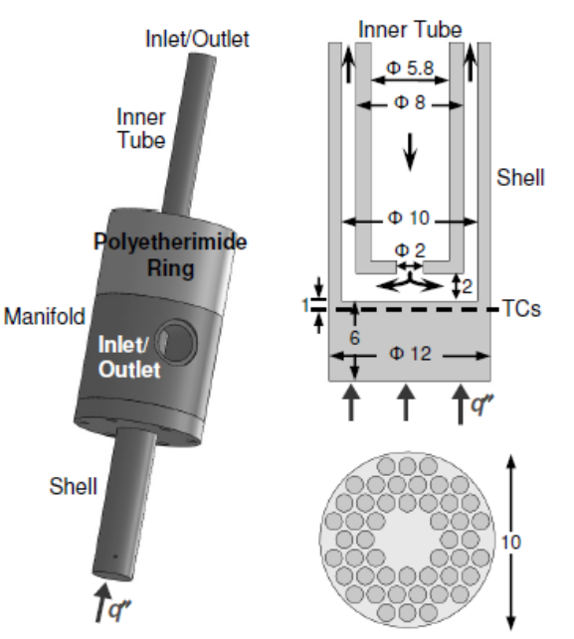
P/D =1.2
Fig. 2. Diametric slice of the experimentally tested test section [left] and a top view of the 48 pin-fin array with diameter D = 1 mm fins on a P = 1.2 mm pitch [right]⁵. Dimensions are given in mm.

Nevertheless, the combination of the impinging jet and the pin-fin array did increase the pressure drop above the values for either the impinging jet or the fin array alone. The objective of this numerical investigation was therefore to determine if there were other pin-fin array configurations that would also enhance cooling performance with minimal increase in the pressure drop.

III. Numerical Model

Experimental testing of divertor modules with different fin configurations is quite costly because of machining costs. This study therefore focused on a numerical approach, which enabled rapid and cost-effective evaluation of a large number of different configurations. A series of 12 numerical models with different pin-fin configurations were chosen to cover a wide range of parameters (Fig. 3). All the computational fluid dynamics (CFD) simulations were performed using ANSYS® FLUENT® 14.0 (Ref. 8).
All 12 models were 45 mm in axial extent; all other model dimensions were identical to those shown in Fig. 2 except that the axial distance between the inner and the outer surfaces of the pressure boundary was 1 mm (Refs. 1, 3) (vs. the 6 mm shown in Fig. 2). The test was assumed to be constructed from a W-1% La₂O₃ alloy, WL-10, which has been proposed as a high-temperature structural material for several divertor designs⁴. Each model, which consisted only of 30° “slice” of the module because of its twelve-fold radial symmetry, was composed of ~3×10⁶ unstructured tetrahedral cells. . In each case, He enters the inner channel at 600 °C and ~10 MPa and a boundary condition of a uniform heat flux of 10 MW/m² is imposed at the heated outer surface of the pressure boundary.
A
C
B
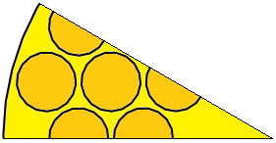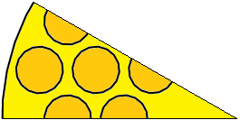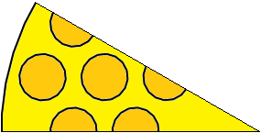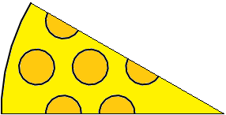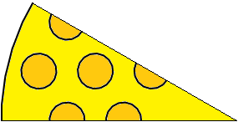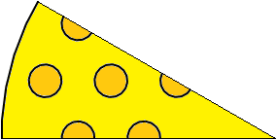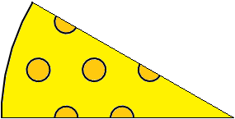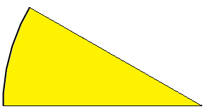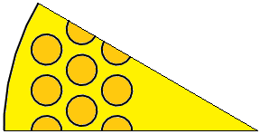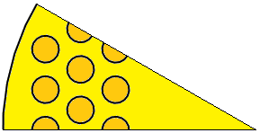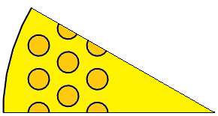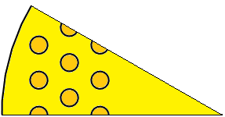
L
K
J
I
H
G
F
E
D
Fig. 3. Fin arrangement of all cases tested. Dashed border indicates baseline case. Solid border indicates the best performing cases for the individual arrays.

Each configuration was simulated at the same four flow rates corresponding to jet Reynolds numbers, Re_{j}, of 4.5×10⁴, 6.0×10⁴, 7.5×10⁴, and 9.0×10⁴:

$$Re_{j}=\frac{4\dot{m}}{πD_{j}{\text{μ}}_{i}}$$

where $\dot{m}$ is the mass flow rate, D_{j} is the jet diameter (2 mm), and ${\text{μ}}_{i}$ is the dynamic viscosity based on the inlet temperature of 600 °C. The realizable k-ε turbulence model⁹ with enhanced wall treatment was used in all the simulations.
The performance of the two “baseline cases” indicated by the dashed rectangles in Fig. 3 were compared against the other configurations. The first baseline case, the configuration without any fins, should have the worst thermal performance. The second baseline case, which closely resembles the experimentally tested divertor configuration, has 1 mm OD fins arranged in a 1.2 mm pitch hexagonal array, giving a total of 48 fins over the entire cooled inner surface of the divertor (Fig. 2 [right]).
The thermal-hydraulic performance of each model subject to the same incident heat flux of 10 MW/m² was based upon two metrics. The first is the average temperature of the heated side of the pressure boundary,$\overline{T_{s}}$. Given that the WL-10 alloy needs to operate between 800-1200°C, i.e. between its ductile-brittle transition and recrystallization temperatures⁴, designs with the lowest $\overline{T_{s}}$ (exceeding 800 °C) are desirable because they provide the greatest operating temperature margin.
The second metric used to evaluate the thermal performance is the pressure drop,$Δp$. Minimizing $Δp$ for each divertor module will result in significant operating cost savings by reducing pumping power requirements. The divertor cooling system operating at nominal prototypical flow rates under normal, steady-state conditions should have pumping power requirements that are at most 10% of the incident thermal power from the fusion plasma. It should be noted that this study only considers the thermal-hydraulic performance of these pin-fin configurations; additional studies would be needed to confirm that these configurations do not exceed thermal stress limits.

IV. SIMULATIONS

To evaluate the effect of the boundary condition at the tips of the fins, results were compared for otherwise identical simulations of the second baseline case for adiabatic and conducting fin-tip boundary conditions to model the effect of non-contacting and perfectly contacting fin tips. The maximum difference in $\overline{T_{s}}$ was about <2°C and the value of $Δp$ was nearly identical over the entire ranged of Re_{j}. Given that the boundary condition at the fin tips appears to have almost no effect on the simulations, all the remaining configurations were simulated with a conducting fin-tip boundary condition, corresponding to the assumption that the fin tips are in perfect contact inlet tube.
A series of models was constructed using fins of varying diameters D, while maintaining the same pitch P = 1.2 mm and number of fins (48) as the baseline case. Cases A-G had P/D = 1.1, 1.2, 1.33, 1.5, 1.6, 2.0, and 2.4. For these cases, the total cooled surface area, A_{c}, which includes the area on the “sides” and tips of the fins uncovered by the inlet tube, as well as the area of the cooled surface not covered by the fins, increases as D increases, resulting in a larger heat transfer area. Increasing A_{c} does not necessarily lead to improved performance, however, as shown in Table I, which compares numerical predictions at the prototypical value of Re_{j} = 75,000 (Ref. 5). The case with the lowest $\overline{T_{s}}$ = 824 °C at this Re_{j} is case C, the configuration where P/D = 1.33, which has a pressure drop of 506 kPa. In general, for a given pitch, an array of fins with smaller D (for a given number of fins) have smaller $Δp$ values, presumably because there is a larger gap between the fins.
TABLE I. Data for 48 fin arrays with P = 1.2 mm at Re_{j} = 75,000
Case | P/D | A_{c}  [mm²] | $$Δp$$  [kPa] | $$\overline{T_{s}}$$  [°C]
A | 1.1 | 388 | 729 | 836
B | 1.2 | 361 | 531 | 848
C | 1.33 | 329 | 506 | 823
D | 1.5 | 304 | 498 | 828
E | 1.6 | 291 | 500 | 836
F | 2.0 | 250 | 502 | 839
G | 2.4 | 223 | 501 | 842
H | Bare | 79 | 459 | 875

As shown in Fig. 4, the peak heat transfer coefficient (HTC) at the prototypical flow rate for the baseline case without fins occurs near r = 1.25 mm. When fins are located too close to the peak, they interfere with the spreading of the impinging jet and thus increase$Δp$. If a new fin array still has as large a A_{c} as the array with fins closer to the jet, then by locating fins just outside this zone, the effect of the fins can be maximized by producing a lower $Δp$.

HTC [kW/m²K]
r [mm]

Fig. 4. Local HTC versus radial position r for the case without fins at Re_{j} = 75,000. Locally averaged values are dark circles (●). The location of the center of closest fin for the two arrays tested is shown by the dotted lines.

A similar study as performed on the 48 pin array was conducted using a triangular array with a smaller pitch P = 0.8 mm. Reducing the pitch increases the total number of fins to 84 over the inner surface of the pressure boundary, or four half and five whole pin fins per 30° segment as shown in Fig. 3. Four Cases I-L with P/D = 1.33, 1.5, 1.6, and 2.0 were evaluated. Though these fins have a smaller D, the fin array still has A_{c} similar to that for cases A-G simply because there are more fins. As shown in Table II, cases J&K with P/D = 1.5 and 1.6 have the lowest $\overline{T_{s}}$ = 838 °C with a similar $Δp$ at the nominal flow rate. Since the fins for case K are smaller and thus potentially easier to machine, it is preferred over case J. As shown in Table II, moving the fins outward resulted in a modest decrease in $Δp$ for cases I-L even though A_{c} is similar to the cases presented in Table I.
TABLE II. Data for 84 fin arrays with P = 0.8 mm at Re_{j} = 75,000
Case | P/D | A_{c}  [mm²] | $$Δp$$  [kPa] | $$\overline{T_{s}}$$  [°C]
H | Bare | 79 | 459 | 875
I | 1.33 | 380 | 499 | 845
J | 1.5 | 348 | 500 | 838
K | 1.6 | 332 | 499 | 838
L | 2.0 | 283 | 497 | 842

$$\overline{T_{s}} [°C]$$
Re_{j} ×10⁻⁴

Fig. 5. $\overline{T_{s}}$ vs. Re_{j} for the optimized cases. Bare (●), experimentally studied array with P/D = 1.2 (■), 48 fin array with P/D = 1.33 (♦), and 84 fin array with P/D = 1.6 (▲).
Comparing $\overline{T_{s}}$ and $Δp$ of the best performers, namely cases C and K, with the two baseline cases in Figs. 5 and 6, respectively, shows that both $\overline{T_{s}}$ and $Δp$ are lower for cases C and K at all Re_{j} tested (25°C & 5% and 10°C & 6%, respectively at the prototypical Re_{j}), indicating that these new pin-fin array configurations should cool more effectively and efficiently than the experimentally tested array. Compared to the case without fins at the prototypical flow rate, case C reduces $\overline{T_{s}}$ by 52°C with a 10% increase in $Δp$ while case K reduces $\overline{T_{s}}$ by 37 °C with a 9% increase in $Δp$. The geometric details of the two optimum fin arrangements are shown in Fig. 7.

%
Re_{j} ×10⁻⁴

Fig. 6. $Δp$ as a percentage of bare $Δp$ vs. Re_{j}. Experimentally studied array with P/D = 1.2 (■), 48 fin array with P/D = 1.33 (♦), and 84 fin array with P/D = 1.6 (▲).

The gap between the fins in both of the optimum designs is 0.3 mm and it may be difficult to consistently fabricate a pin-fin array with such small gaps. These results suggest cases D and L with slightly larger P/D, which would increase the gap width, has a thermal performance, at least in terms of $\overline{T_{s}}$ and$Δp$, nearly as good as the optimal cases C and K, respectively. As demonstrated here, this divertor design can be improved by adding an array of pin-fins to the cooled surface even if their specifications are not exactly as the specified optimum designs.
C
K
P = 1.2
D = 0.9
5
5
30°
P = 0.8
D = 0.5
30°

Fig. 7. Details of the optimum array geometries for 48 fin array [left] and 84 fin array [right]. Dimensions in mm.

V. CONCLUSIONS

Previous experimental studies of a HEMP-like divertor module design showed that using the combination of an impinging jet and a pin-fin array consisting of 48 fins with a diameter of 1 mm and a pitch of 1.2 mm could enhance divertor thermal performance.
However, only one pin-fin array configuration consisting of identical cylindrical fins was studied in this experiment, and no attempt was made to optimize the array geometry in these earlier studies. Numerical simulations using a commercial CFD software package were therefore performed to determine a pin-fin array design (consisting of identical cylindrical fins) that would optimize the thermal performance. These simulations considered two cylindrical fins of varying diameter at two different pitch values P = 0.8 mm and 1.2 mm, corresponding to a total of 84 and 48 fins, respectively. An optimum fin diameter D was determined for each value of P. These studies showed that the boundary condition at the fins tips, and hence the type and extent of the contact between the fins and the end of the inner tube, had a negligible effect on the thermal performance. This result suggests that the performance of these fins is fairly robust with respect to minor geometric variations in the fin height due, for example, to manufacturing tolerances.
For 48 fins at P = 1.2 mm, the optimum design with P/D = 1.33 predicts decreases in both the average heated surface temperature of the pressure boundary,$\overline{T_{s}}$, and pressure drop,$Δp$, compared to the original experimentally tested array over a range of flow rates spanning the prototypical flow rate of Re_{j} = 7.5×10⁴. This optimized pin-fin array reduces $\overline{T_{s}}$ by 52 °C, but increases $Δp$ by 10%, compared to the same divertor without fins.
For an array of 84 fins at P = 0.8 mm, the optimum design with P/D = 1.6 also predicts decreases in $\overline{T_{s}}$ and $Δp$ compared to the experimentally tested array over the same range of flow rates. The optimum design for the 84 fin array also reduces $\overline{T_{s}}$ by 37 °C and increases $Δp$ by 9% compared to the same divertor without fins at the prototypical flow rate.
When comparing the two optimum designs, though the decrease in $Δp$ is predicted to be slightly larger for the 84 fin design at the prototypical flow rate, the 48 fin design predicts a more significant decrease in $\overline{T_{s}}$. Also, as the 0.3 mm gap between the fins for both optimum designs may yet still be too small to consistently machine, the results of these studies indicate that designs with slightly smaller fins and thus a larger inter-fin gap may still provide significant performance improvements over both the experimentally tested design with fins and the design without fins. The performance of the fin array should therefore also be fairly robust with respect to small variations in the fin diameter and pitch as well as the pin height.
Also, these simulations should be viewed as merely a guide and not as making exact performance predictions. We have confidence in the results as similar techniques as those used in this report were used to accurately predict the performance of previous experiments. Furthermore, as the simulations were performed using a consistent methodology, the trends shown are expected to be real. Experimental studies are the only true proving ground for any divertor design and in light of this, we plan next to fabricate and experimentally test these “optimal” pin-fin arrays.

Acknowledgments

This work was performed as a part of the ARIES study. We thank the U.S. DOE Office of Fusion Energy Sciences for their support through contract number DE-FG-02-01ER54656.
REFERENCES

- T. IHLI, ET AL., “An advanced He-cooled divertor concept: Design, cooling technology, and thermohydraulic analyses with CFD,” Fusion Engineering and Design, 75-79, 371 (2005).
- S. HERMSMEYER and S. MALANG, “Gas-cooled high performance divertor for a power plant,” Fusion Engineering and Design, 61-62, 197-202 (2002).
- E. DIEGELE, ET AL., “Modular He-cooled divertor for power plant application,” Fusion Engineering and Design, 66-68, 383 (2003).
- T. CHEVTOV, ET AL., “Status of He-cooled Divertor Development (PPCS Subtask TW4-TRP-001-D2),” P. NORAJITRA, Ed., Forschungszentrum Karlsruhe, Karlsruhe (2005).
- B. H. MILLS, ET AL., “Experimental Investigation of Fin Enhancement for Gas-Cooled Divertor Concepts,” Fusion Science and Technology, 60, 190 (2011).
- B. H. MILLS, ET AL., “Dynamically similar studies of the thermal performance of helium-cooled finger-type divertors with and without fins,” Accepted by Fusion Science and Technology.
- J. D. RADER, ET AL., “Experimental and Numerical Investigation of Thermal Performance of Gas-Cooled Jet-Impingement Finger-Type Divertor Concept,” Fusion Science and Technology, 60, 223 (2011).
- ANSYS® FLUENT®, Release 14.0, ANSYS, Inc.
- T.-H. SHIH, ET AL., “A new k-ε eddy-viscosity model for high Reynolds number turbulent flows - model development and validation”. Computers Fluids. 24(3). 227 (1995).

