MAGNETIC PROTECTION OF THE FIRST WALL

A.E.ROBSON
Consultant/NRL

ABSTRACT

It is shown that a cusp magnetic field, centered on the pellet, can
protect the first wall from the impact of charged reaction products.

HAPL Meeting
02-05-2004
PRINCIPLE OF MAGNETIC PROTECTION - I

• An axially symmetric magnetic field is described by a vector potential A(0, A_{θ}, 0)

• A charged particle in this field has canonical angular momentum, p_{θ}, given by

$p_{θ}={\text{mru}}_{θ}+\frac{q}{c}{\text{rA}}_{θ}$

[m is the particle mass; q = Ze is the charge; u_{θ} is the azimuthal component of velocity]

• In the absence of collisions, p_{θ} is conserved

PRINCIPLE OF MAGNETIC PROTECTION - II

• For particles originating on the axis, p_{θ} = 0.

• A particle with total velocity u will necessarily be excluded from the region where

$\left|A_{θ}\right|≥A^{}=\frac{\text{muc}}{q}$

• To be protected, the first wall should be situated in a region where $\left|A_{θ}\right|≥A^{}$

VALUES OF A* NEEDED FOR MAGNETIC PROTECTION

A* FOR THE PRINCIPAL REACTION PRODUCTS

Particle: | ⁴He | ³H | ¹H | ³He
Energy (MeV): | 3.50 | 1.01 | 3.02 | 0.82
u (cm.s⁻¹): | 1.3 × 10⁹ | 8.0 × 10⁸ | 2.4 ×10⁹ | 7.2 × 10⁸
A* (G-cm): | 2.7 × 10⁵ | 2.5 × 10⁵ | 2.5 × 10⁵ | 1.1 × 10⁵

Note 1: The ³H and ¹H from the D-D reaction penetrate the field
almost as far as the ⁴He from the D-T reaction.

Note 2: A* is equivalent to the product Bρ_{L}, where ρ_{L} is the Larmor radius of the particle in the local field B.

MAGNETIC PROTECTION BY A CUSP FIELD

A cusp field system is usually represented by two coils carrying opposing currents:

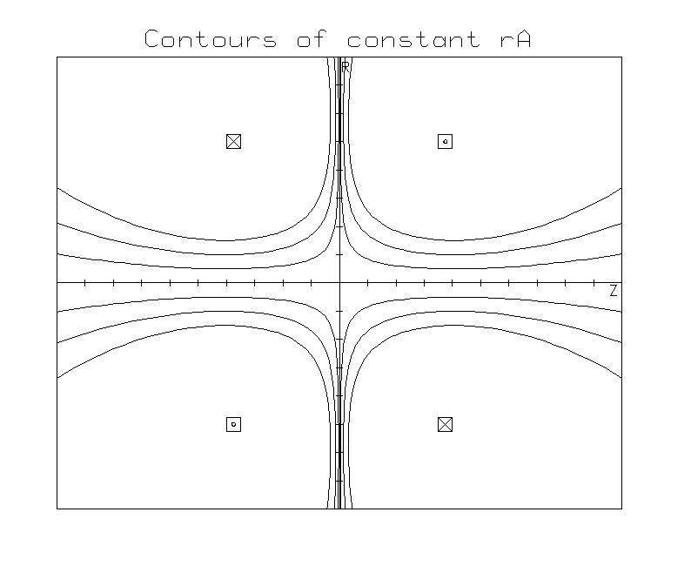
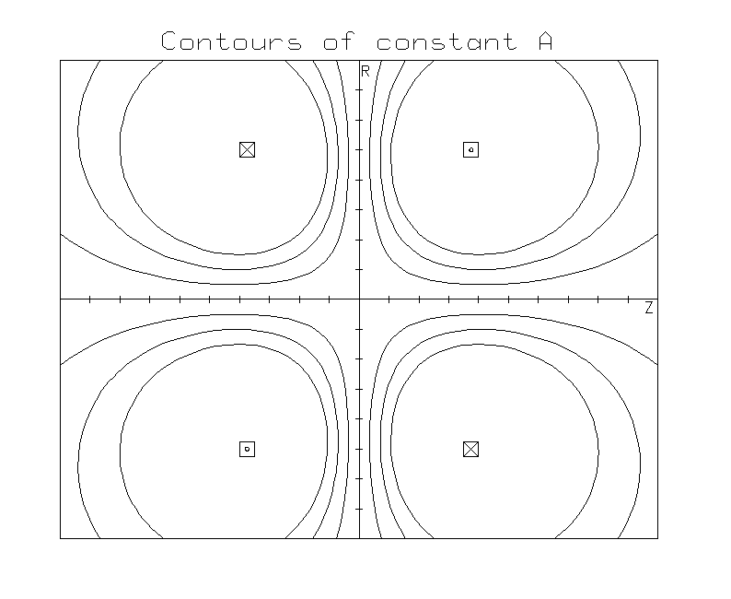

Note that the surfaces of constant A are not the same as the flux surfaces (which are surfaces of constant rA). The surface A = A* forms a magnetic bottle for the energetic reaction products.

HOLES IN THE CUSP MAGNETIC BOTTLE

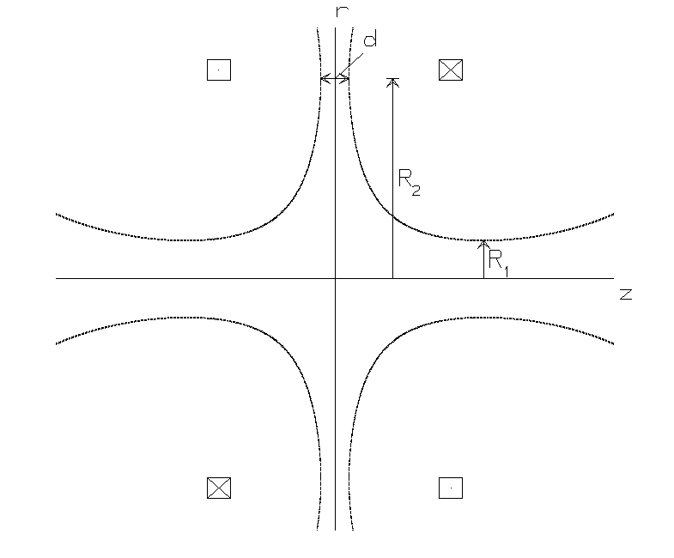

The magnetic bottle has three escape holes:

one ring cusp, area
A_{r} = 2πR₂d

two spindle cusps, area
A_{s} = 2 × πR₁²

d and R₁ are each equal to the Larmor diameter, as defined by the respective fields in each cusp.

In general, A_{r} >> A_{s}

A FULL-SCALE EXAMPLE (for illustrative purposes only)

A cusp system formed by multiple coils allows the position and size of the ring and spindle cusps to be chosen independently. The following example consists of 8 coil pairs arranged on a 10m diameter sphere, forming a bi-conical magnetic bottle.

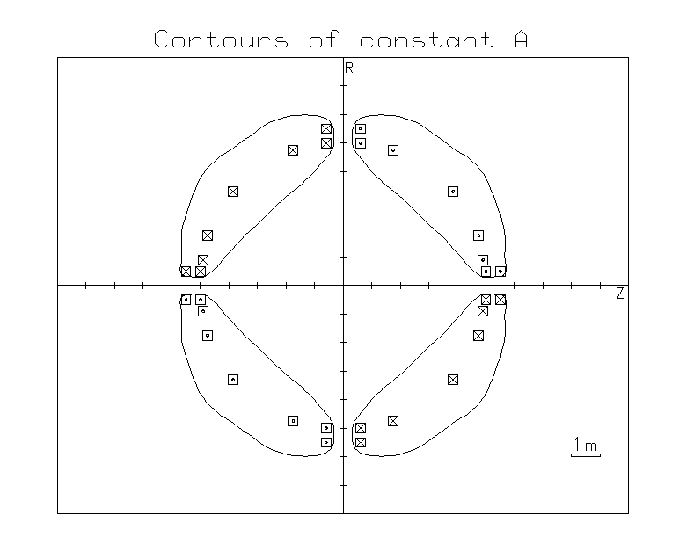
Current in each coil:
0.69 MA-turns

Surface shown:
A = 3 × 10⁵ Gauss-cm
(= 1.1 A* for ⁴He)

Ring cusp:
B = 9.3 kG, d = 64 cm

Spindle cusp:
B = 20.7 kG, R₁ = 28 cm

A FULL-SCALE EXAMPLE (continued)

The total area of the escape holes represents about 9% of the surface area of the bi-conical bottle. This is the probability of escape on each transit.

The transit time of a ⁴He across the bottle is approximately 0.5μs, so the mean containment time is approximately 5μs.

The magnetic energy in the cusp system is approximately 58 MJ. Compare this to the energy in charged reaction products of about 32 MJ (for a 160MJ pellet).

The magnetic field will be displaced and compressed by the expanding plasma. If a conducting surface, closed in the azimuthal direction, is placed along the
A = 1.1 A* contour, the flux function rA will be conserved at each point on it. Thus A will be conserved on the entire surface and ⁴He ions will be unable to reach it.

SUMMARY

• A suitably designed cusp magnetic field can prevent charged reaction products from reaching the first wall. This is ensured by the conservation of canonical angular momentum, a powerful constraint.

• The design of the first wall is simplified since it now has only to resist neutrons and x-rays.

• The reaction products are channeled out through the cusps into external dump chambers, facilitating the clearing of the reactor chamber between shots.

• The partial containment in the cusp magnetic bottle extends by an order of magnitude the duration of the pulse at the surfaces on which the particles eventually land, ameliorating the materials problem.

• The difficulty in incorporating a coil system into the already complicated reactor (blanket, beamlines, etc.) may render the whole idea impracticable.

